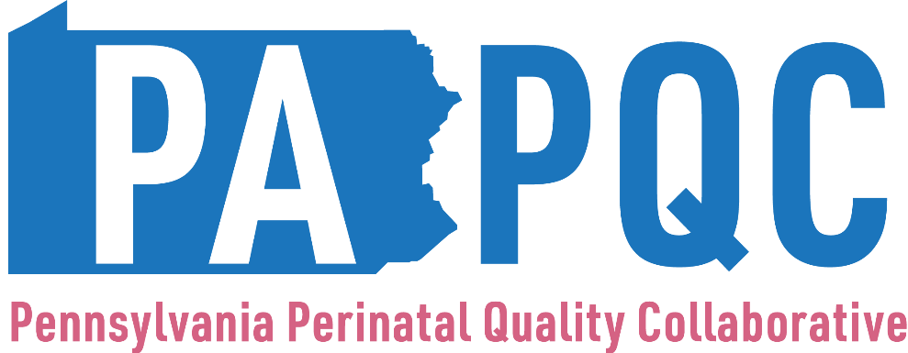

Safe Sleep
Survey
(Structure Measures)

Please work with your team to complete this birth site-level survey for the designated quarter.

- What is your PA PQC Hospital or Affiliation? (dropdown box)

- What is your name? (text box)

3. What is your title/role? (text box)

Provider Education and Training

- Has your hospital conducted an environmental audit to identify safe sleep barriers in the last year?
- Dropdown list
  - Yes
  - In progress
  - Have not started

- Has your hospital revised any policies procedures, or environment based on barriers identified?
- Dropdown list
  - Yes
  - In progress
  - Have not started
  - No barriers identified

Caregiver Education

- Has your safe sleep caregiver education been reviewed by a patient partner?
- Multiple choice
  - Yes
  - In progress
  - Have not started

- Do you have a caregiver survey that evaluates the effectiveness of safe sleep caregiver education and materials?
- Multiple choice
  - Yes
  - In progress
  - Have not started

- Is safe sleep education and screening a standard practice at every pediatric and family practice visit for infants up to one year of age?
- Multiple choice
  - Yes
  - No
  - Working on it

Community Partnership

- Are safe sleep education materials provided in languages other than English and Spanish in obstetric and pediatric outpatient clinics?
- Multiple choice
  - Yes
  - In progress
  - Have not started

- Are you partnering with organizations outside your healthcare system to promote consistent messaging for safe sleep education?
- Multiple choice
  - Yes
  - In progress
  - Have not started

- Does your hospital/clinic partner with organizations that provide access to safe sleep surfaces?
- Multiple choice
  - Yes
  - In progress
  - Have not started

- Does your hospital provide safe sleep items to patients at discharge?
- Multiple choice
  - Yes
  - In progress
  - Have not started

If yes: What safe sleep item(s) does your hospital provide to patients at discharge?
- Choose all that apply
  - Safe sleep surface
  - Sleep sack
  - Other: please comment

Policies

- Has your inpatient safe sleep policy been reviewed in the last year and is it applicable to every patient under 1 year of age?
- Multiple choice
  - Yes
  - In progress
  - Have not started

- Has your outpatient OBGYN safe sleep policy been reviewed in the last year, does it include frequency and timing of education, and is it applicable to every prenatal and postpartum patient?
- Multiple choice
  - Yes
  - In progress
  - Have not started

- Has your outpatient Pediatrics safe sleep policy been reviewed in the last year, does it include frequency and timing of education, and is it applicable to every patient under 1 year of age?
- Multiple choice
  - Yes
  - In progress
  - Have not started

- Has your outpatient Family Practice safe sleep policy been reviewed in the last year, does it include frequency and timing of education, and is it applicable to every patient under 1 year of age?
- Multiple choice
  - Yes
  - In progress
  - Have not started

- Are the safe sleep policies readily available and easily accessible to all staff?
- Multiple choice
  - Yes
  - In progress
  - Have not started

