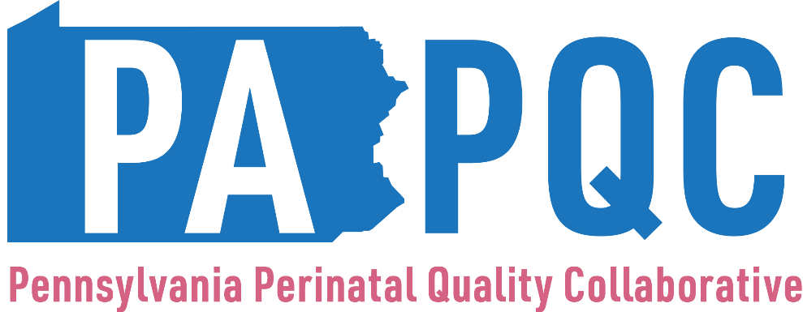

Substance Exposed Newborn (SEN) / Neonatal Abstinence Syndrome (NAS) Survey
(Structure Measures)

Please work with your team to complete this birth site-level survey for the designated quarter.

- At the end of the quarter, what cumulative percentage of nurses caring for newborns in the nursey and/or NICU have been trained on validated assessments for NAS in the past year? (Report estimate in 10% increments; round up)

  - Please select the validated assessment your team is using: (please check all that apply)
    - Finnegan
    - Modified Finnegan
    - Eat Sleep Console Care Tool
    - Other (please specify)

- Does your PA PQC hospital have quality improvement efforts in place to increase and maintain inter-rater reliability for NAS assessments?

  - Yes
  - In progress
  - Have not started

- Is your hospital using standardized definitions for Substance Exposed Newborns (SENs)?
*Note: The PA PQC defines SEN as in-utero exposure to any alcohol or other drug (AOD) substance.
  - Yes
    - If yes, please provide the definition for SEN
  - In progress
  - Have not started

- Is your hospital using standardized definitions for Neonatal Abstinence Syndrome (NAS)?
*Note: The PA PQC defines NAS as clinical signs of withdrawal from in-utero exposure due to any of the following prescription or illicit drugs:
(a) opioids (which includes Medication for OUD (e.g., buprenorphine and methadone), natural opioids (e.g., morphine, codeine), semisynthetic opioids (e.g., heroin), and synthetic opioids (e.g., fentanyl, or fentanyl analogs), or opioid metabolites (e.g., 6-monoacetylmorphine);
(b) benzodiazepines (e.g., diazepam, alprazolam); or
(c) barbiturates(e.g., phenobarbital).
(Please note that the sub-set of NAS related to opioids is often referred to as Neonatal Opioid Withdrawal Syndrome or NOWS. The above definition for NAS includes but is not limited to NOWS.)

    - Yes, and we use the “confirmed” and “probable” case definitions for NAS defined in the Council of State and Territorial Epidemiologists’ (CSTE) NAS Standardize Case Definition and used by PA DOH (please see the Tier 1 Confirmed and Probable NAS case definitions on pages 7 and 8 at https://cdn.ymaws.com/www.cste.org/resource/resmgr/2019ps/final/19-MCH-01_final_7.31.19.pdf, and please see PA DOH’s NAS FAQ at https://www.whamglobal.org/list-documents/157-nas-pa-icms-implementation-faq-1/file)
    - Yes, but we use a different standardized case definition for NAS
      - Please specify the definition
    - In progress
    - Have not started

- Does your hospital have a standardized process in place for assigning a standardized list of ICD-10 diagnosis codes for an infant diagnosed with NAS?
  - Yes, in place
    - If yes: (please select the ICD-10 codes that are on your hospital’s standardized list for NAS.)
*For guidance on when to use these codes in the context of “confirmed” vs. “suspected” NAS, please see “Tier 2” guidance on pages 10 and 11 and Appendix 5 in the CSTE NAS Standardized Case Definition used by PA DOH at https://cdn.ymaws.com/www.cste.org/resource/resmgr/2019ps/final/19-MCH-01_final_7.31.19.pdf)
      - P96.1 Neonatal withdrawal symptoms from maternal use of drugs of addiction (recommended for neonates with clinical signs of withdrawal and confirmed neonatal or maternal laboratory results or maternal history)
      - P04.14 Newborn affected by maternal use of opiates (recommend only for suspected cases)
      - P04.17 Newborn affected by maternal use of sedative-hypnotics (recommended only for suspected cases)
      - P04.1A Newborn affected by maternal use of anxiolytics (recommended only for suspected cases)
      - Other (please list each ICD-10 code)

  - Yes, in place, but our hospital’s standardized list for NAS includes other or additional ICD-10 codes
    - (please list each ICD-10 code)
  - In progress
  - Have not started
- Does your hospital have a standardized process in place for assigning a standardized list of ICD-10 diagnosis codes for all SENs that are not diagnosed with NAS?
  - Yes, in place
    - (please select the ICD-10 codes that are on your hospital’s standardized list for all SENs that are not diagnosed with NAS)
    - P04.11 Newborn affected by maternal antineoplastic chemotherapy
    - P04.12 Newborn affected by maternal cytotoxic drugs
    - P04.13 Newborn affected by maternal use of anticonvulsants
    - P04.15 Newborn affected by maternal use of antidepressants
    - P04.16 Newborn affected by maternal use of amphetamines
    - P04.18 Newborn affected by other maternal medication
    - P04.41 Newborn affected by maternal use of cocaine
    - P04.42 Newborn affected by maternal use of hallucinogens
    - P04.49 Newborn affected by maternal use of other drugs of addiction
    - P04.2 Newborn affected by maternal use of tobacco
    - P04.3 Newborn affected by maternal use of alcohol
    - P04.5 Newborn affected by maternal use of nutritional chemical substances
    - P04.6 Newborn affected by maternal exposure to environmental chemical substances
    - P04.81 Newborn affected by maternal use of cannabis
    - P04.89 Newborn affected by other maternal noxious substances
  - Yes, in place but our hospital’s standardized list for all SENs that are not diagnosed with NAS includes other or additional ICD-10 codes (please list each ICD-10 code)
  - In progress
  - Have not started
(Please note that the term “affected by” in the above list of ICD-10 codes comes from the international ICD-10 code description. As recommended by the CSTE NAS Standardized Case Definitions, the codes in the list above may be used for infants exposed prenatally to drugs/substances that can cause withdrawal signs (known via maternal history/laboratory testing or neonatal laboratory testing) but does not show signs of withdrawal. For additional guidance, please see Appendix 5 in the CSTE NAS Standardized Case Definition at https://cdn.ymaws.com/www.cste.org/resource/resmgr/2019ps/final/19-MCH-01_final_7.31.19.pdf).

- At the end of this reporting period, what cumulative proportion of neonatal providers and nursing staff have received within the last two years an education program on respectful and equitable care? (Report estimate in 10% increments; round up)

- Has your hospital established breastmilk feeding guidelines and parameters based on national guidelines for parents with SUD (including OUD) and caregivers, AND does your hospital’s written guideline support breastfeeding among mothers who are taking prescribed medications for OUD without contraindications for breastfeeding? (An example of a national guideline can be obtained here https://www.ncbi.nlm.nih.gov/pmc/articles/PMC4378642/, and an example of a visual “Traffic Light” guideline can be obtained here https://gallery.mailchimp.com/244750cf0d942e5d1b1ca3201/files/e93d6b02-6dfc-471b-bac3-3b01a2dfa17f/Breastfeeding_Traffic_Light_Revised.pdf)
- Yes
  - If yes, has your hospital educated staff on these guidelines and how to empower patients to make informed decisions about breastmilk feeding that support the health of their newborn?
    - Yes
    - In progress
    - Have not started
  - In progress
  - Have not started

- Does your hospital have standardized pharmacologic treatment protocols for NAS?
  - Yes
  - In progress
  - Have not started

- Does your hospital have standardized non-pharmacologic treatment protocols for NAS?
  - Yes
    - If yes, please indicate the non-pharmacological interventions that are in place and part of the protocol: (check all that apply)
      - Rooming in
      - Parent/caregiver presence
      - Skin-to-skin contact
      - Holding by parent/caregiver/cuddler to help calm infant and aid in sleep
      - Safe and effective swaddling
      - Optimal feeding
      - Non-nutritive sucking
      - Quiet and low light environment
      - Rhythmic movement
      - Additional help/support in room
      - Limiting number of visitors and duration of visits to minimize disruptions in infant’s care environment and sleep
      - Clustering care and assessments with infant’s awake times
      - Safe sleep/fall prevention
      - Parent/caregiver self-care and rest
      - Other (please specify)
  - In progress
  - Have not started
- Has your newborn care team (providers, nurses, and social workers) been educated on the criteria for Plans of Safe Care, their role in establishing and initiating the Plans of Safe Care, and how to explain it to families in accordance with your hospital’s, county’s, and state’s guidelines and policies? Answer Yes for policies and education completed
  - Yes
  - In progress
  - Have not started

- Has your newborn care team been educated on the criteria, protocols, and best practices for referring substance-exposed newborns and families to post-discharge services and supports? Answer Yes for policies and education completed

  - Yes: (Check all that apply)
    - early intervention
    - home visiting services
    - physicians experienced with NAS
    - high-risk infant follow-up clinic / developmental assessment clinic
  - In progress
  - Have not started

- Has your neonatal care team (providers, nurses, and social workers) created a protocol for closing the loop on the referral status with the post-discharge services and supports? Answer Yes for policies and education completed

  - Yes (Check all that apply)
    - early intervention
    - home visiting services
    - physicians experienced in working with NAS
    - high-risk infant follow-up clinic / developmental assessment clinic
  - If yes, does this process also include notifying the family’s outpatient primary provider?
    - Yes
    - No
    - Other
  - In progress
  - Have not started

