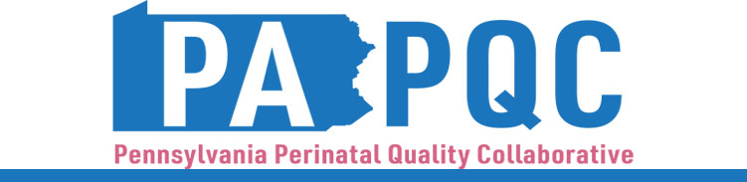

PA PQC Virtual Regional Networking Session
Wednesday, November 12
10:30 a.m. to 12:00 p.m. ET
Virtual

Learning Objectives:
- Identify Urgent Maternal Warning Signs
- Discuss region-specific needs related to UMWS patient education

Agenda:

10:30 a.m. to 10:35 a.m. – Welcome – Jennifer Condel, SCT(ASCP)MT, Senior Program Manager, Perinatal Health

10:35 a.m. to 11:05 a.m. – Urgent Maternal Warning Signs Training for Non-medical Social Service Providers – Aasta Mehta, MD, MPP, PA PQC Advisory Co-Chair

11:05 a.m. to 11:10 a.m. – Urgent Maternal Warning Signs Sprint Overview and Future Collaboration– Jennifer Condel, SCT(ASCP)MT, Senior Program Manager, Perinatal Health

11:10 a.m. to 11:27 a.m. – PA PQC Sprint Peer-to-Peer Presentations– Maureen Saxon-Gioia, MSHSA, BSN, RN, PA PQC QI Coach, Jewish Healthcare Foundation

11:27 a.m. to 11:55 a.m. – Region-Specific Breakouts for Collaboration

Northwest/Southwest – facilitated by Jennifer Condel, SCT(ASCP)MT, Manager, Lead QI Coach, Jewish Healthcare Foundation and Lisa Boyd, PA PQC Data Manager and QI Coach, Jewish Healthcare Foundation

Northeast – facilitated by Karena Moran, PhD, QI Coach and NEPaPQC Manager

Southeast – facilitated by Maureen Saxon-Gioia, MSHSA, BSN, RN, PA PQC QI Coach, Jewish Healthcare Foundation and Aasta Mehta, MD, MPP, PA PQC Advisory Group Co-Chair

Lehigh/Capitol – facilitated by Kristen Brenneman, MSN, PA PQC QI Coach, Jewish Healthcare Foundation and Hadar Re’em, Program Associate, Jewish Healthcare Foundation

11:55 a.m. to 12:00 p.m. – Wrap-up & Next Steps – Lisa Boyd, PA PQC Data Manager and QI Coach, Jewish Healthcare Foundation

