PA PQC 11/12/25 Virtual Session Contact List and Map
Organizations in attendance at the PA PQC 11/12 Virtual Session, represented on the map below:
Pin # | Organization | PA PQC Region
1 | Geisinger Free2BMom | NE
2 | Sincere Inspiration Doula Services LLC | SE
3 | Maternal & Family Health Services | NE, L/C, SE
4 | Maternal and Child Health Consortium | SE
5 | FIRST Center | L/C
6 | Nurse Family Partnership/Family First Health | L/C
7 | Erie Family Center | NW
8 | UPMC Hamot | NW
9 | A Woman's Place | SE
10 | Baby Love at Hamilton Health Center | L/C
11 | AHN Forbes | SW
12 | AHN Saint Vincent Hospital | NW
13 | AHN West Penn Hospital | SW
14 | AHN Wexford | SW
15 | Allegheny County Health Department | SW
16 | Armstrong County Memorial Hospital | SW
17 | Broad Top Medical Center | L/C
18 | CCBH | SW
19 | HAVIN, Inc. | SW
20 | Hospital of the University of Pennsylvania | SE
21 | Jefferson Einstein Philadelphia Hospital (formerly Einstein Medical Center) | SE
22 | Journeys: A Program for Children and Families | L/C
23 | Mercer County Children and Youth Services | NW
24 | Monroe County Children and Youth | NE
25 | Moses Taylor Hospital - Labor & Delivery | NE
26 | Mount Nittany Medical Center | NE
27 | Nurse-Family Partnership of Chester County | SE
28 | Outreach Center for Community Resources | NE
29 | PDPH ReACH | SE
30 | Penn Highlands Healthcare DuBois Neonatal ICU | NW
31 | Penn Medicine Doylestown Hospital | SE
32 | Penn Medicine Lancaster General Women and Babies | L/C
33 | Penn State College of Medicine | L/C
34 | Penn State Health Milton S. Hershey Medical Center | L/C
35 | Penn State Health St. Joseph Regional Medical Center | L/C
36 | Phoenixville Hospital, Tower Health | SE
37 | Reclaim Black Motherhood | SE
38 | St. Clair Hospital | SW
39 | The Health Federation of Philadelphia | SE
40 | The Wright Center | NE
41 | Today Is A Good Day | SE
42 | Trinity Health - St. Mary Medical Center | SE
43 | UPMC Altoona | SW
44 | UPMC Harrisburg | L/C
45 | UPMC Williamsport/UPMC Northcentral PA | NE
46 | WellSpan Chambersburg Hospital Family Birthing | L/C
47 | WVU Medicine Uniontown Hospital | SW
48 | Maternity Care Coalition | SE

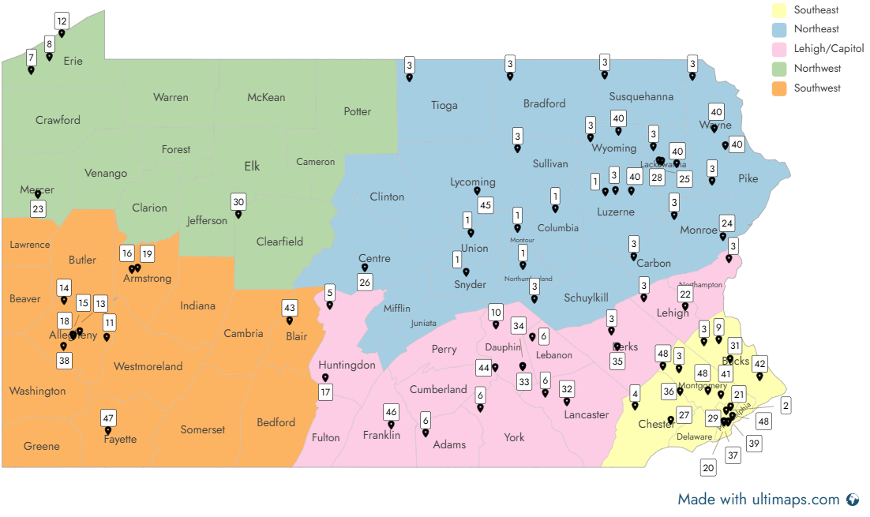
PA PQC 11/12/25 Regional Virtual Session Attendees
Comments Shared During PA PQC 11/12 Virtual Session (numbers correspond with pin numbers on the map)
- Behavioral Health Case Manager, Geisinger Free2BMom (NE) plan to distribute the Urgent Maternal Warning Signs with our intake packet for pregnant and postpartum moms with SUD and make it a point of discussion.
- Khamyia “Myia” Jackson - Sincere Inspiration Doula Services LLC in Philadelphia. We offer on demand teaching virtually and in person birth education and labor assistance for the family we accept Medicaid. https://sites.google.com/sincereinspiration.info/thevillageguru/home
- Maternal & Family Health Services (NE, L/C, SE ) - Scranton Healthy Beginnings Plus (NE) partners with Commonwealth Health Moses Taylor Our Nurse Educator also provides Community Education on various maternal topics including Maternal Warning Signs. The program is called Baby Bump and Beyond in person in Scranton on Virtual Live: Link education at https://mfhs.org/classes/.
  - Family Partnership Nurse Home Visitor Program: We cover Lackawanna, Susquehanna, Wayne and Luzerne Counties. We work closely with MFHS Maternity Clinic for coordination of care.
- Nursing Supervisor- Nurse Family Partnership/Family First Health York and Adams County ( L/C) work with first time pregnant mothers. High risk, low income. Home based/evidence based model. RN's visit in home and stay with the new mom from pregnancy through age two. Not currently collaborating with hospital systems regarding maternal health concerns but open to collaborations as we have strong relationships with Wellspan and UPMC.
- Erie Family Center (NW) – I support families in a Parents as Teachers program and utilize our home visiting curriculum to support education about prenatal and postpartum wellness. I support prenatal, birth and postpartum families alongside a parent educator to provide resources, family well-being support and screenings (mental health and developmental) for the whole family
- Rachele Daniels - Medical Educator, A Woman's Place (SE). I can provide Trainings on domestic violence for healthcare providers in Bucks County, PA.

Additional contacts and notes shared:
- Pennsylvania Neonatal Abstinence Syndrome Family Guide Toolkit from Department of Health | Commonwealth of Pennsylvania. Call Bureau of Family Health at 717-783-8143 to request NAS books free of charge as long as funding allows.
- JusticeWorks YouthCare has a broad service area, click here for service counties in PA
- Melissa Snyder - RDH, BASDH, M.Ed., PHDHP, Public Health Dental Hygiene Practitioner, Geisinger Health Plan. (NW): Erie, Crawford, Warren, Forest, Venango, Mercer, Clarion, Jefferson, Lawrence, Butler, Armstrong
- Sue McCullough - NW Region: will share resources in upcoming Community Infant toddler Expo. Community Partners and Expecting/New mothers attend.
- St. Clair Hospital (SW) - Pittsburgh, PA - we are using Community Education classes to reach out to the community BEFORE birth to spread the word on Urgent Maternal Warning Signs
The following entities were also represented on the PA PQC 11/12 Virtual Session and have many locations in the regions noted or statewide service areas:
- WellSpan Health (L/C)
- Jefferson Health (SE)
- Main Line Health (SE)

Statewide:
- Clinical Connect HIE
- United Healthcare
- Volunteers of America PA
- PA DHS – Office of Child Development and Early Learning

Resources referenced during the PA PQC 11/12 Regional Virtual Session
Talking to a Provider
- Find more conversation guides and other resources at: cdc.gov/HearHer
- You know your body best (cdc.gov)
Community Resources
- PA Navigate: PA Navigate Online Resource Portal
- CDC's Hear Her: Providing Support for Pregnant or Postpartum People | HEAR HER Campaign | CDC
  - HEAR HER one-pager: HEAR HER CONCERNS: Listening and Acting Quickly could save her life (cdc.gov)
- AIM (Alliance for Innovation on Maternal Health): https://saferbirth.org/aim-resources/aim-cornerstones/urgent-maternal-warning-signs/
- AWHONN (Association of Women’s Health, Obstetric and Neonatal Nurses): https://www.awhonn.org/education/post-birth-warning-signs-education-program/
- Birth Justice Philly: www.birthjusticephilly.com
  - Link to Urgent Maternal Warning Signs training on their website: https://www.birthjusticephilly.com/earlywarningsigns

Urgent Maternal Warning Signs Tools
- https://saferbirth.org/aim-resources/aim-cornerstones/urgent-maternal-warning-signs
- https://www.cdc.gov/hearher/maternal-warning-signs/index.html
- https://saveyourlife.awhonn.org/Default.aspx

Materials from Session: https://www.papqc.org/events/materials-from-sessions

