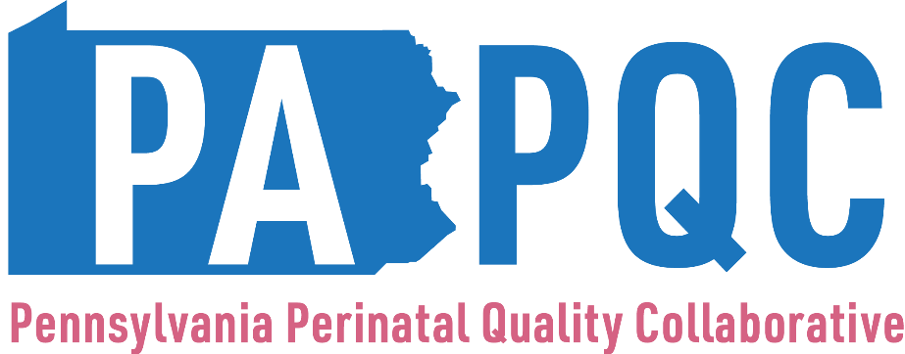

2025-2026 Designations Dates to Remember

2024-25 Post-Designations Survey Dates
- February 28 – Survey opens
- March 31 – Submissions due
- April 30 – PA PQC staff will reach out with specific questions, as needed
- May 9 – Answers to clarifying question(s) due

2025-26 Pre-Designations Survey Dates
- May 19 – Survey opens
- June 13 – Submissions due
- July 11 – PA PQC staff will reach out with additional information requests, as needed
- July 25 - All revised submissions due

