Action Item  (What Will Happen) | By Whom  (Team Member/Role) | Target Date | Status | Outcomes  (Results/Barriers)
Action Item  (What Will Happen) | By Whom  (Team Member/Role) | Target Date | Status | Outcomes  (Results/Barriers)

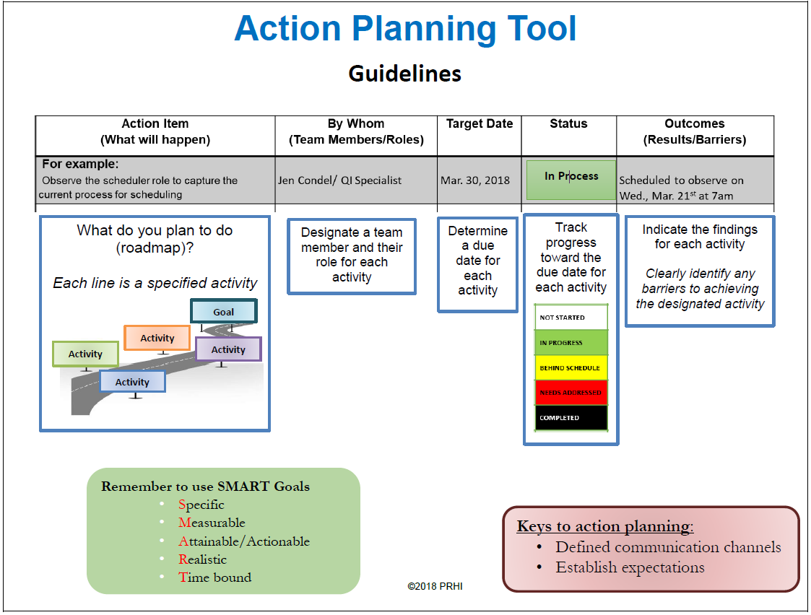
Review current process for patient education on UMWS
March 30, 2025

