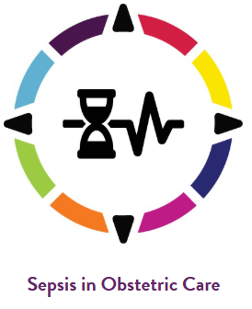



Urgent Maternal Warning Signs Sprint Finale

Topics Covered:
- “Act” part of PDSA
  - Adjust workflow based on barriers
  - Conduct the next PDSA
  - Continue PDSA cycles to expand Urgent Maternal Warning Signs (UMWS) patient education to ED, OB outpatient, etc.
- Sustainment of UMWS patient education
  - Establish new best practice – develop a plan for compliance monitoring and integrate continued PDSA cycles into sustainment
    - Consider whether the roles for monitoring the new UMWS patient education process are effective and efficient
    - Identify the key process measures your team will continuously track
    - What processes are in place to ensure education is provided to staff routinely? (e.g. new hire education plan)
  - Spread and disseminate to peers
- Peer-to-peer discussion on progress throughout the course of the Sprint, next steps in implementing UMWS patient education, and questions for peers

Next Steps:
□ Troubleshoot remaining workflow issues, adjust as needed
□ Develop UMWS patient education sustainment plan
□ Create and implement an assessment of your team’s UMWS Sprint journey

All resources pertaining to this session can be found in the Urgent Maternal Warning Signs Sprint Materials folder on the PA PQC website.

